User Guide

======================================================================

1) Click on the Tennessee Valley Old Time Fiddlers’ Convention app button on your phone to open the application.

See Figure 1.1.

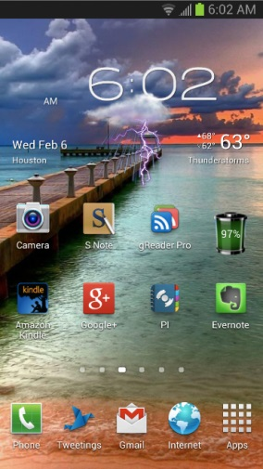



Figure 1.1

2) At the Home screen, choose which option you would like by clicking on the button. Select “General Information”.

See fig. 1.2.

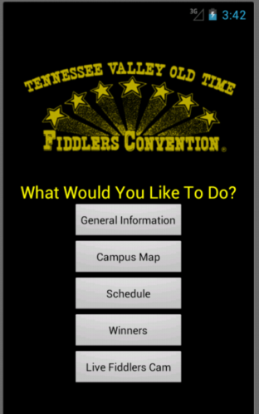

Figure 1.2

3) This brings you to the General Information Screen on the TVOTFC website and displays a welcome message regarding the convention. To go to the next page, click on the red arrow on the bottom right hand corner of the screen.

See fig. 2.0.



Figure 2.0

4) The next page gives Admission Details including hours, cost, and a message about pets and coolers. Again, to go to the next page, click on the red arrow on the bottom right corner of the screen. See figure 2.1.

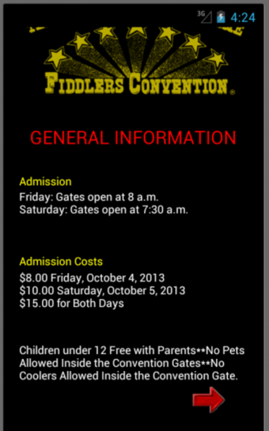

Figure 2.1

5) The last General Information page lists some considerations. To go back to the application’s Home screen, click on the red House button on the bottom right corner of the screen.

See figure 2.2.

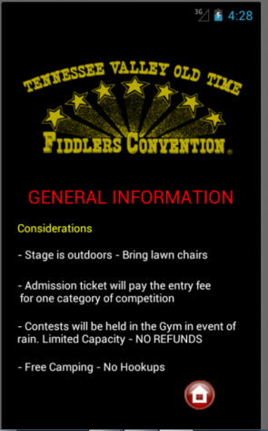

Figure 2.2

6) From the Home page, select “Campus Map”. See fig. 3.0.



Figure 3.0

7) The Campus Map appears on the screen. It is shown in landscape mode, but will realign in portrait mode if you turn your phone upright. You can zoom in by using your fingers to make a pinching motion. To zoom out, simply make the opposite motion with your fingers ~ pinch out.

See figure 3.1.

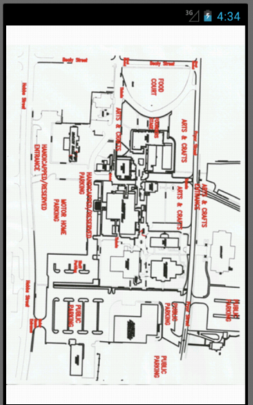

Figure 3.1

8) To go back to the Home page, just hit your phone’s Back Button.

9) From the Home screen, select “Schedule”. See fig. 4.0.



Figure 4.0

10) From the Schedule page, click on the category/contestant that you would like to see the schedule for. You may click on your phone’s Back button to return to the Home screen.

See figure 4.1.

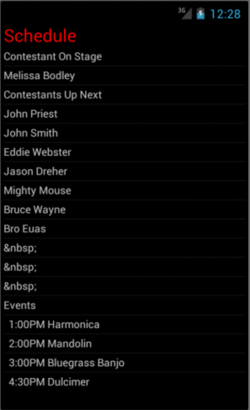

Figure 4.1

11) From the Home screen, select “Winners”. See fig. 5.0.



Figure 5.0

12) The Winners screen displays on the screen. Click the category you would like to see the winners for, and all winners so far for the selected category will display on the screen. Use your phone’s Back button to return to the Home screen.

See figure 5.1.



Figure 5.1

13) From the Home Screen select “Live Fiddlers Cam”. See fig. 6.0.



Figure 6.0

14) This will bring up the live feed of the webcam so you can see remotely what is going on at the convention. Use your phone’s Back button to return to the application’s Home screen.

See figure 6.1.

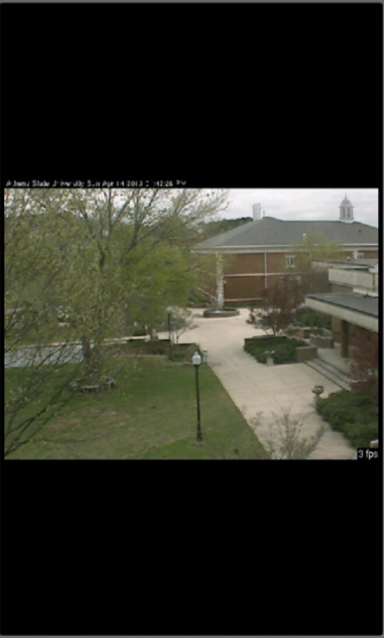

Figure 6.1

That is currently all the app functionality! Hope you enjoy it!